Feature

- Static/demographic, (education, location, model)
- coe_pplan_sub_type_desc
- EQP_PROD_NM
- MARKET_TYPE
- Dynamic/Temporal (daily usage)
  - scaled_percentageReceived
  - scaled_reset_count

Types Of Churn Prediction Models

1. Single Period Models
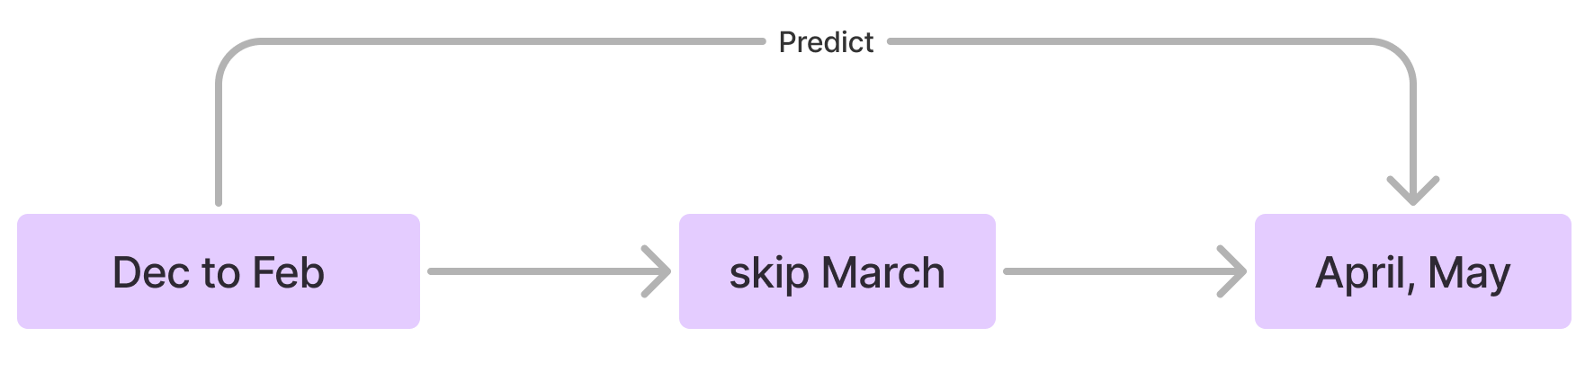
"A Customer Churn Prediction Model in Telecom Industry Using Boosting”
- extract data from Dec, 2009 to Feb, 2010,
- churner label is determined in two-month period of time after March 2010 (April 2010–May 2010),
- March, as “Implementation Zone.”

2. Time Series Models
churn time series classification:
- Nearest-neighbor-based approach to time-series classification

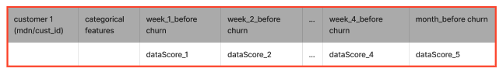

Trend factor is commonly used in financial institution to determine the volatility of an asset with respect to underlying
market. It was used in churn prediction in the telecom industry (Vyas et al. 2018).

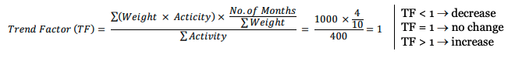

To validate our churn using future data

Experiment

- data sampling strategies(imbalance),
- duration of data used, (Dec to Feb)
- prediction window, (April, May)
- number of multiple time periods (the number of separate time intervals used to train the churn prediction model.)

Kaggle:

Binary Classification with a Bank Churn Dataset
Telco Customer Churn
- https://www.kaggle.com/code/tanmay111999/telco-churn-eda-cv-score-85-f1-score-80
- Outlier!!! The Silent Killer
- CUSTOMER CHURN PREDICTION

Research paper:
- Developing a prediction model for customer churn from electronic banking services using data mining(RF)
- Nearest-neighbor-based approach to time-series classification
- Customer churn prediction for web browsers (Transformer with static and dynamic features)
- Extreme gradient boosting trees with efficient Bayesian optimization for profit-driven customer churn prediction
- Time series for early churn detection: using similarity based classification for dynamic networks

